Web Engineering lab:2

Name: Nisha
Section: F
CMS id: 023-24-0178

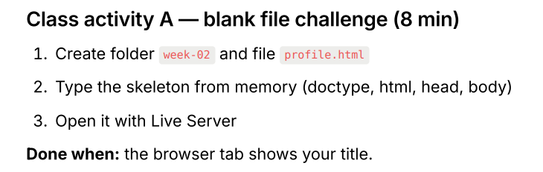
<!DOCTYPE html>
<html>
<head>
<title>My Profile</title>
</head>

<body>
<h1>My Profile</h1>
<p>Welcome to my profile page.</p>
</body>

</html>

Output:
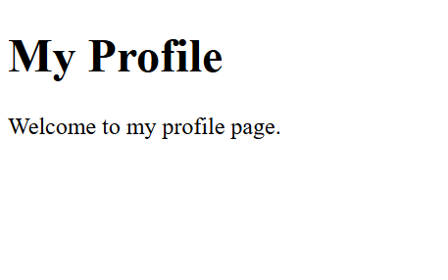

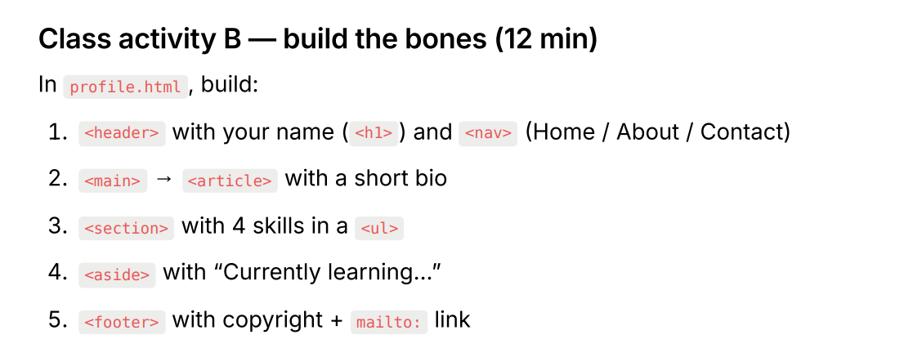
<!DOCTYPE html>
<html>

<head>
<title>My Profile</title>
</head>

<body>

<header>
<h1>Nisha</h1>

<nav>
<a href="#home">Home</a> |
<a href="#about">About</a> |
<a href="#contact">Contact</a>
</nav>
</header>

<section id="home">
<h2>About Me</h2>
<p>
I am a student interested in technology and programming.
I enjoy learning new skills and working on different projects.
</p>
</section>

<section id="about">
<h2>My Skills</h2>
<ul>
<li>HTML</li>
<li>CSS</li>
<li>Python</li>
<li>Java</li>
</ul>
</section>

<section>
<h2>Currently Learning...</h2>
<p>Currently learning Web Development and JavaScript.</p>
</section>

<footer id="contact">
<p>
&copy; 2026 Nisha |
<a href="mailto:nishasadhwani64@gmail.com">Email Me</a>
</p>
</footer>

</body>

</html>

Output:
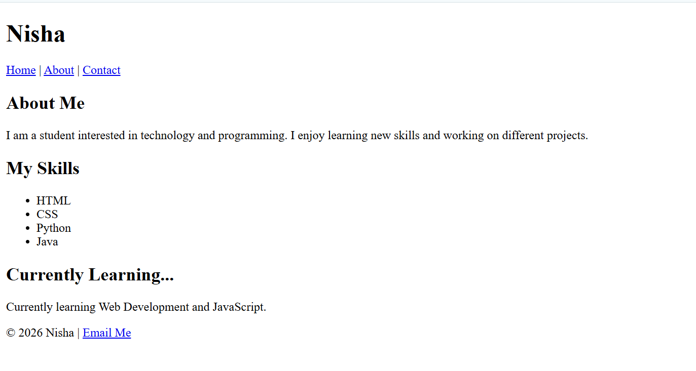

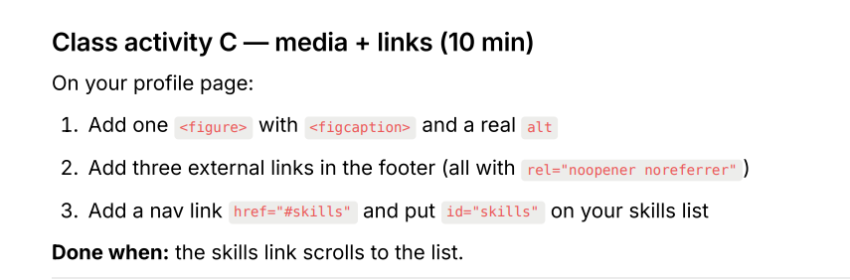
<!DOCTYPE html>
<html>

<head>
<title>My Profile</title>
</head>

<body>

<header>
<h1>Nisha</h1>

<nav>
<a href="#home">Home</a> |
<a href="#about">About</a> |
<a href="#skills">Skills</a> |
<a href="#contact">Contact</a>
</nav>
</header>

<section id="home">
<h2>Home</h2>

<figure>
<img src="profile.jpg" alt="Nisha profile photo" width="200">
<figcaption>Nisha's Profile</figcaption>
</figure>
</section>

<section id="about">
<h2>About Me</h2>
<p>
I am a student interested in technology and programming.
I enjoy learning new skills and working on different projects.
</p>
</section>

<section id="skills">
<h2>My Skills</h2>
<ul>
<li>HTML</li>
<li>CSS</li>
<li>Python</li>
<li>Java</li>
</ul>
</section>

<section>
<h2>Currently Learning...</h2>
<p>Currently learning Web Development and JavaScript.</p>
</section>

<footer id="contact">
<p>
&copy; 2026 Nisha |
<a href="mailto:nishasadhwani64@gmail.com">Email Me</a>
</p>

<p>
<a href="https://www.google.com" target="_blank" rel="noopener noreferrer">Google</a> |
<a href="https://www.github.com" target="_blank" rel="noopener noreferrer">GitHub</a> |
<a href="https://www.linkedin.com" target="_blank" rel="noopener noreferrer">LinkedIn</a>
</p>
</footer>

</body>

</html>

Output:
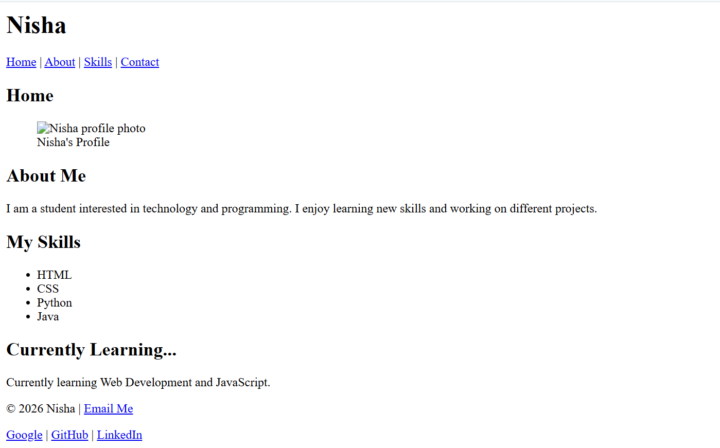

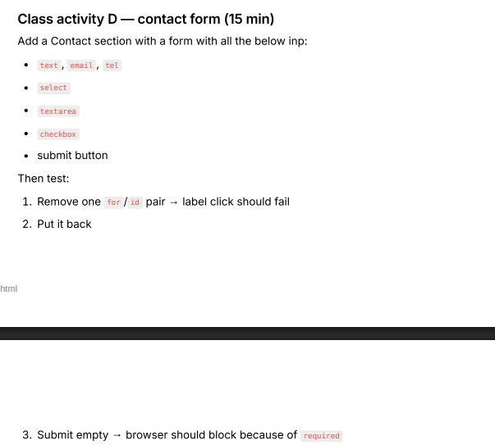
<!DOCTYPE html>
<html>

<head>
<title>My Profile</title>
</head>

<body>

<header>
<h1>Nisha</h1>

<nav>
<a href="#home">Home</a> |
<a href="#about">About</a> |
<a href="#skills">Skills</a> |
<a href="#contact">Contact</a>
</nav>
</header>

<section id="home">
<h2>Home</h2>

<figure>
<img src="profile.jpg" alt="Nisha profile photo" width="200">
<figcaption>Nisha's Profile</figcaption>
</figure>
</section>

<section id="about">
<h2>About Me</h2>
<p>
I am a student interested in technology and programming.
I enjoy learning new skills and working on different projects.
</p>
</section>

<section id="skills">
<h2>My Skills</h2>

<ul>
<li>HTML</li>
<li>CSS</li>
<li>Python</li>
<li>Java</li>
</ul>
</section>

<section>
<h2>Currently Learning...</h2>
<p>Currently learning Web Development and JavaScript.</p>
</section>

<section id="contact">
<h2>Contact Me</h2>

<form>

<label for="name">Name:</label>
<input type="text" id="name" name="name" required>
<br><br>

<label for="email">Email:</label>
<input type="email" id="email" name="email" required>
<br><br>

<label for="phone">Phone:</label>
<input type="tel" id="phone" name="phone" required>
<br><br>

<label for="subject">Subject:</label>
<select id="subject" name="subject" required>
<option value="">Select a subject</option>
<option value="general">Compiler Construction</option>
<option value="project">Web Engineering</option>
<option value="feedback">Machine Learning</option>
</select>
<br><br>

<label for="message">Message:</label>
<br>
<textarea id="message" name="message" rows="5" cols="30" required></textarea>
<br><br>

<label for="updates">
<input type="checkbox" id="updates" name="updates">
Send me updates
</label>
<br><br>

<button type="submit">Submit</button>

</form>
</section>

<footer>
<p>
&copy; 2026 Nisha |
<a href="mailto:nishasadhwani64@gmail.com">Email Me</a>
</p>

<p>
<a href="https://www.google.com" target="_blank" rel="noopener noreferrer">Google</a> |
<a href="https://www.github.com" target="_blank" rel="noopener noreferrer">GitHub</a> |
<a href="https://www.linkedin.com" target="_blank" rel="noopener noreferrer">LinkedIn</a>
</p>
</footer>

</body>

</html>

Output:
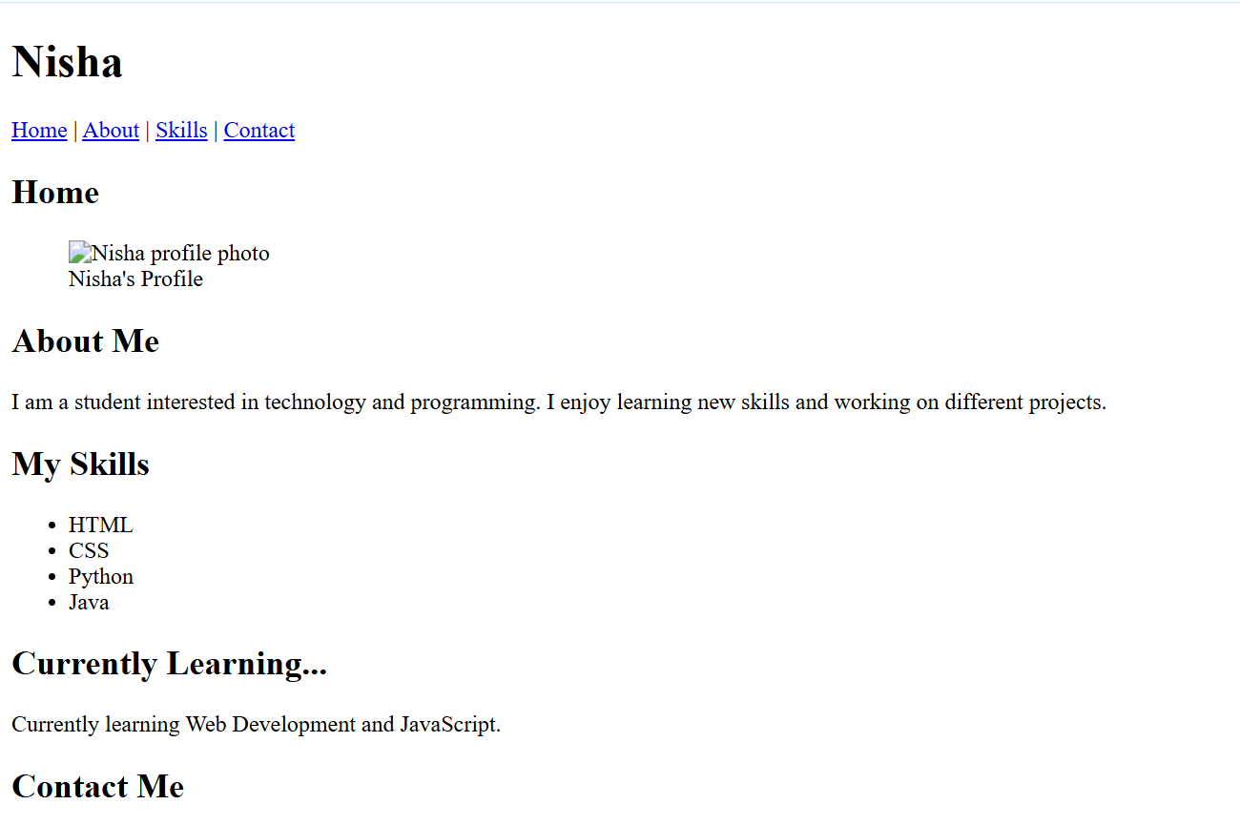
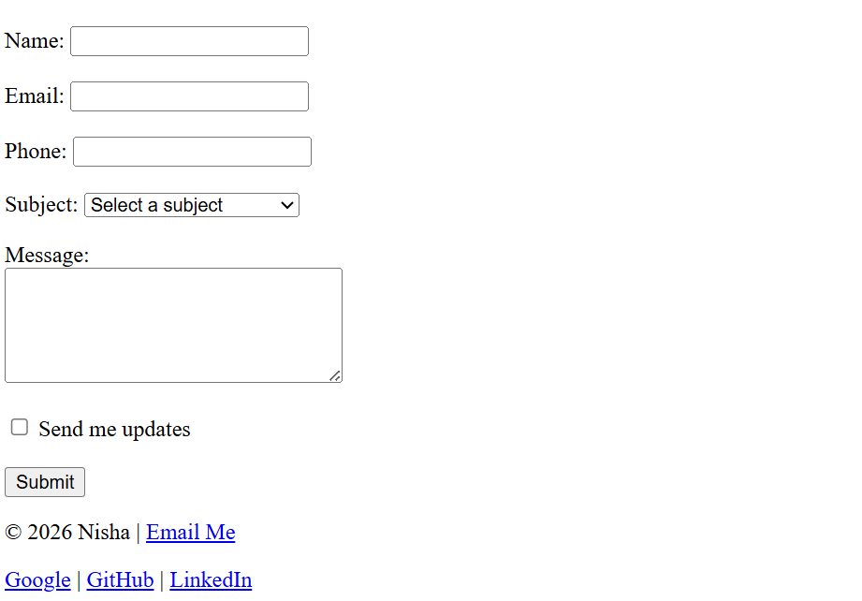

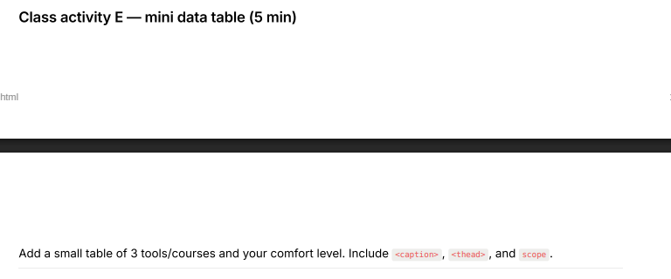
<!DOCTYPE html>
<html>

<head>
<title>My Profile</title>
</head>

<body>

<header>
<h1>Nisha</h1>

<nav>
<a href="#home">Home</a> |
<a href="#about">About</a> |
<a href="#skills">Skills</a> |
<a href="#contact">Contact</a>
</nav>
</header>

<section id="home">
<h2>Home</h2>

<figure>
<img src="profile.jpg" alt="Nisha profile photo" width="200">
<figcaption>Nisha's Profile</figcaption>
</figure>
</section>

<section id="about">
<h2>About Me</h2>
<p>
I am a student interested in technology and programming.
I enjoy learning new skills and working on different projects.
</p>
</section>

<section id="skills">
<h2>My Skills</h2>

<ul>
<li>HTML</li>
<li>CSS</li>
<li>Python</li>
<li>Java</li>
</ul>
</section>

<section>
<h2>Currently Learning...</h2>
<p>Currently learning Web Development and JavaScript.</p>
</section>

<section>
<h2>My Learning Comfort Level</h2>

<table border="1">
<caption>Tools and Courses Comfort Level</caption>

<thead>
<tr>
<th scope="col">Tool/Course</th>
<th scope="col">Comfort Level</th>
</tr>
</thead>

<tbody>
<tr>
<th scope="row">HTML</th>
<td>High</td>
</tr>

<tr>
<th scope="row">Python</th>
<td>Medium</td>
</tr>

<tr>
<th scope="row">Machine Learning</th>
<td>Beginner</td>
</tr>
</tbody>
</table>
</section>

<section id="contact">
<h2>Contact Me</h2>

<form>

<label for="name">Name:</label>
<input type="text" id="name" name="name" required>
<br><br>

<label for="email">Email:</label>
<input type="email" id="email" name="email" required>
<br><br>

<label for="phone">Phone:</label>
<input type="tel" id="phone" name="phone" required>
<br><br>

<label for="subject">Subject:</label>
<select id="subject" name="subject" required>
<option value="">Select a subject</option>
<option value="compiler">Compiler Construction</option>
<option value="web">Web Engineering</option>
<option value="ml">Machine Learning</option>
</select>
<br><br>

<label for="message">Message:</label>
<br>
<textarea id="message" name="message" rows="5" cols="30" required></textarea>
<br><br>

<label for="updates">
<input type="checkbox" id="updates" name="updates">
Send me updates
</label>
<br><br>

<button type="submit">Submit</button>

</form>
</section>

<footer>
<p>
&copy; 2026 Nisha |
<a href="mailto:nishasadhwani64@gmail.com">Email Me</a>
</p>

<p>
<a href="https://www.google.com" target="_blank" rel="noopener noreferrer">Google</a> |
<a href="https://github.com" target="_blank" rel="noopener noreferrer">GitHub</a> |
<a href="https://www.linkedin.com" target="_blank" rel="noopener noreferrer">LinkedIn</a>
</p>
</footer>

</body>

</html>

Output:
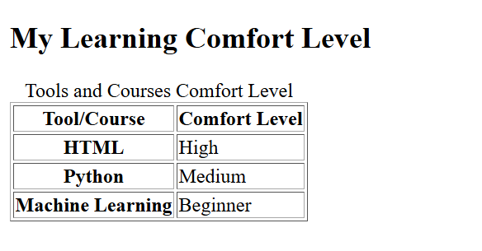

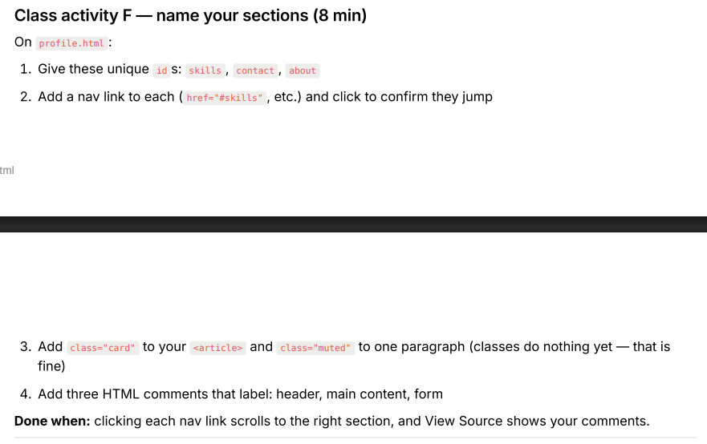
<!DOCTYPE html>
<html>

<head>
<title>My Profile</title>
</head>

<body>

<!-- Header -->
<header>
<h1>Nisha</h1>

<nav>
<a href="#about">About</a> |
<a href="#skills">Skills</a> |
<a href="#contact">Contact</a>
</nav>
</header>

<!-- Main Content -->
<main>

<section id="about">
<h2>About Me</h2>

<article class="card">
<p class="muted">
I am a student interested in technology and programming.
I enjoy learning new skills and working on different projects.
</p>
</article>
</section>

<section id="skills">
<h2>My Skills</h2>

<ul>
<li>HTML</li>
<li>CSS</li>
<li>Python</li>
<li>Java</li>
</ul>
</section>

<section>
<h2>Currently Learning...</h2>
<p>Currently learning Web Development and JavaScript.</p>
</section>

<section>
<h2>My Learning Comfort Level</h2>

<table border="1">
<caption>Tools and Courses Comfort Level</caption>

<thead>
<tr>
<th scope="col">Tool/Course</th>
<th scope="col">Comfort Level</th>
</tr>
</thead>

<tbody>
<tr>
<th scope="row">HTML</th>
<td>High</td>
</tr>

<tr>
<th scope="row">Python</th>
<td>Medium</td>
</tr>

<tr>
<th scope="row">Machine Learning</th>
<td>Beginner</td>
</tr>
</tbody>
</table>
</section>

<!-- Form -->
<section id="contact">
<h2>Contact Me</h2>

<form>

<label for="name">Name:</label>
<input type="text" id="name" name="name" required>
<br><br>

<label for="email">Email:</label>
<input type="email" id="email" name="email" required>
<br><br>

<label for="phone">Phone:</label>
<input type="tel" id="phone" name="phone" required>
<br><br>

<label for="subject">Subject:</label>
<select id="subject" name="subject" required>
<option value="">Select a subject</option>
<option value="compiler">Compiler Construction</option>
<option value="web">Web Engineering</option>
<option value="ml">Machine Learning</option>
</select>
<br><br>

<label for="message">Message:</label>
<br>
<textarea id="message" name="message" rows="5" cols="30" required></textarea>
<br><br>

<label for="updates">
<input type="checkbox" id="updates" name="updates">
Send me updates
</label>
<br><br>

<button type="submit">Submit</button>

</form>
</section>

</main>

<footer>
<p>
&copy; 2026 Nisha |
<a href="mailto:nishasadhwani64@gmail.com">Email Me</a>
</p>

<p>
<a href="https://www.google.com" target="_blank" rel="noopener noreferrer">Google</a> |
<a href="https://github.com" target="_blank" rel="noopener noreferrer">GitHub</a> |
<a href="https://www.linkedin.com" target="_blank" rel="noopener noreferrer">LinkedIn</a>
</p>
</footer>

</body>

</html>

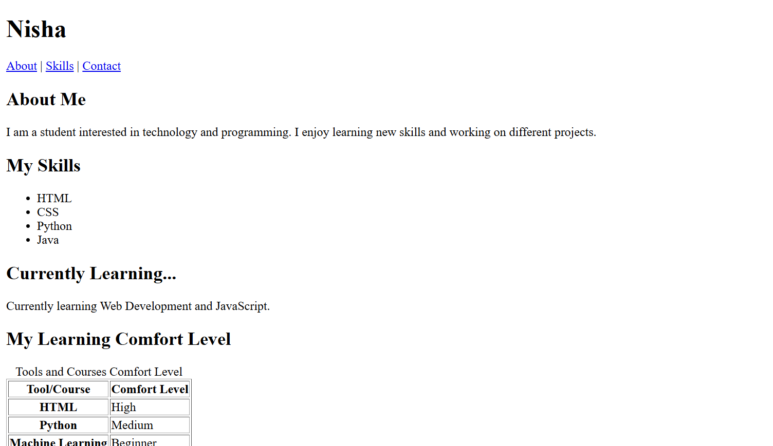

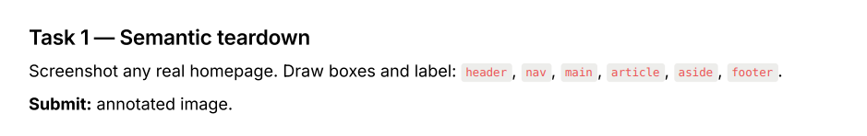

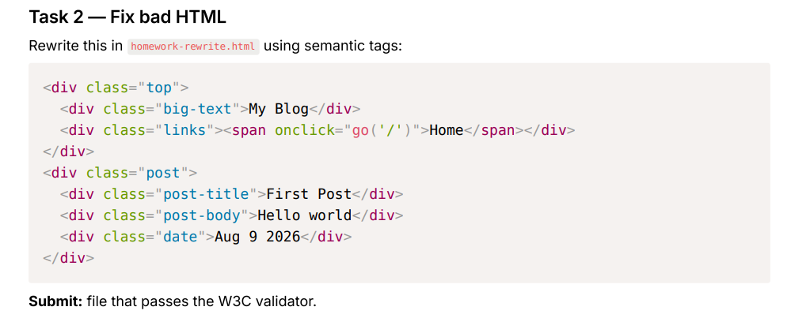
<!DOCTYPE html>
<html>
<head>
<title>My Blog</title>
</head>
<body>

<header>
<h1>My Blog</h1>

<nav>
<a href="/">Home</a>
</nav>
</header>

<main>
<article>
<h2>First Post</h2>
<p>Hello world</p>
<time datetime="2026-03-09">Aug 9 2026</time>
</article>
</main>

</body>
</html>

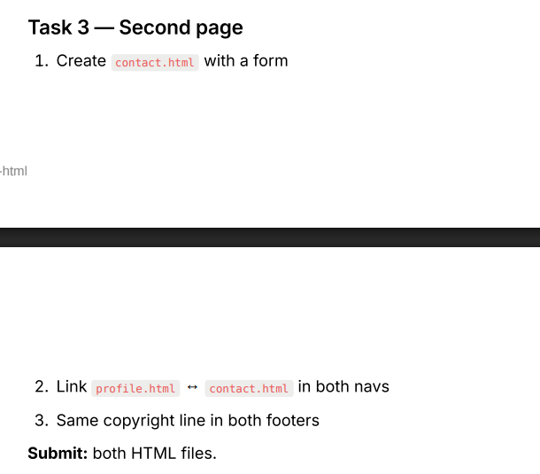
Profile.html
<!DOCTYPE html>
<html>
<head>
<title>My Profile</title>
</head>

<body>

<!-- Header -->
<header>
<h1>Nisha</h1>

<nav>
<a href="profile.html">Home</a>
<a href="profile.html#about">About</a>
<a href="profile.html#skills">Skills</a>
<a href="contact.html">Contact</a>
</nav>
</header>

<!-- Main Content -->
<main>

<section id="about">
<h2>About Me</h2>
<p class="muted">I am a Computer Science student interested in web development and AI.</p>
</section>

<section id="skills">
<h2>Skills</h2>

<article class="card">
<ul>
<li>HTML</li>
<li>CSS</li>
<li>C++</li>
<li>Java</li>
</ul>
</article>
</section>

<section>
<h2>Learning</h2>
<p>Currently learning Web Engineering.</p>
</section>

<section>
<h2>My Tools and Courses</h2>

<table>
<caption>My Tools/Courses and Comfort Level</caption>

<thead>
<tr>
<th scope="col">Tool/Course</th>
<th scope="col">Comfort Level</th>
</tr>
</thead>

<tbody>
<tr>
<td>HTML</td>
<td>Comfortable</td>
</tr>
<tr>
<td>C++</td>
<td>Comfortable</td>
</tr>
<tr>
<td>Java</td>
<td>Learning</td>
</tr>
</tbody>
</table>
</section>

<section>
<h2>Profile Picture</h2>

<figure>
<img src="https://via.placeholder.com/200" alt="Profile picture of Kalpana">
<figcaption>My Profile Picture</figcaption>
</figure>
</section>

<!-- Form -->
<section id="contact">
<h2>Contact Me</h2>

<form>

<label for="name">Name:</label>
<input type="text" id="name" name="name" required>

<br><br>

<label for="email">Email:</label>
<input type="email" id="email" name="email" required>

<br><br>

<label for="phone">Phone:</label>
<input type="tel" id="phone" name="phone" required>

<br><br>

<label for="subject">Subject:</label>
<select id="subject" name="subject" required>
<option value="">Select a subject</option>
<option value="general">General</option>
<option value="feedback">Feedback</option>
<option value="work">Work</option>
</select>

<br><br>

<label for="message">Message:</label>
<textarea id="message" name="message" required></textarea>

<br><br>

<label for="agree">
<input type="checkbox" id="agree" name="agree" required>
I agree to be contacted.
</label>

<br><br>

<button type="submit">Submit</button>

</form>
</section>

</main>

<footer>

<p>Copyright &copy; 2026 Nisha</p>

<a href="https://github.com" target="_blank" rel="noopener noreferrer">GitHub</a>
<a href="https://www.linkedin.com" target="_blank" rel="noopener noreferrer">LinkedIn</a>
<a href="https://www.w3schools.com" target="_blank" rel="noopener noreferrer">W3Schools</a>

<br><br>

<a href="mailto:nisha65@gmail.com">Email Me</a>

</footer>

</body>
</html>

Contact.html
<!DOCTYPE html>
<html>
<head>
<title>Contact - My Profile</title>
</head>

<body>

<header>
<h1>Contact Me</h1>

<nav>
<a href="profile.html">Home</a>
<a href="profile.html#about">About</a>
<a href="profile.html#skills">Skills</a>
<a href="contact.html">Contact</a>
</nav>
</header>

<main>
<section>
<h2>Contact Form</h2>

<form>
<label for="name">Name:</label>
<input type="text" id="name" name="name" required>

<br><br>

<label for="email">Email:</label>
<input type="email" id="email" name="email" required>

<br><br>

<label for="message">Message:</label>
<textarea id="message" name="message" required></textarea>

<br><br>

<button type="submit">Submit</button>
</form>
</section>
</main>

<footer>
<p>Copyright &copy; 2026 Nisha</p>
</footer>

</body>
</html>

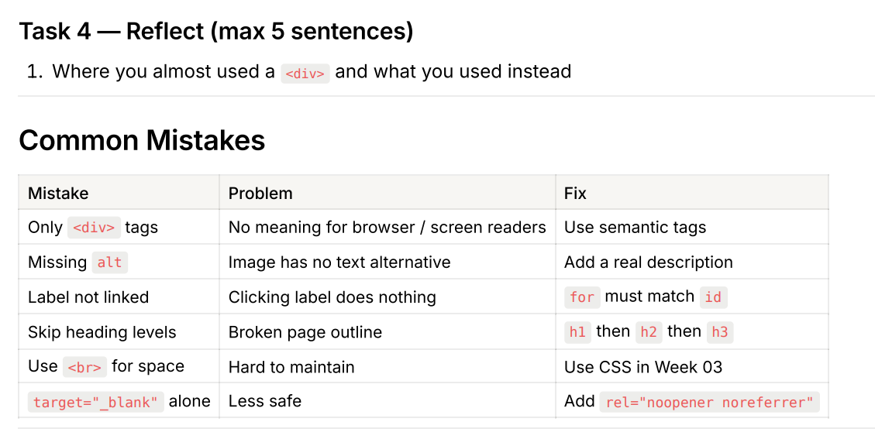
1. Where you almost used a <div> and what you used instead
I almost used a <div> for the main content, but I used <main> and <section> instead.
I learned that semantic tags give meaning to the structure of a webpage.
I made sure every image has a meaningful alt description and every label is linked to its input using for and id.
I also learned to use proper heading levels instead of skipping headings.
I will use CSS for spacing instead of using <br> tags.

